ANALYSIS OF DAMAGE POTENTIAL OF THE 912 GYEONGJU EARTHQUAKE

Cheol-Ho LEE

SUMMARY

This study presents the seismic damage potential of the M5.8 Gyeongju earthquake last year from diverse earthquake engineering perspectives using the accelerograms recorded at three stations near the epicenter. In the time domain, strong motion durations are evaluated and compared with statistical averages of the ground motions with similar magnitude, epicentral distance and soil conditions while Fourier analysis is performed to identify damaging frequency contents contained in the records. Effective peak ground accelerations are evaluated from the calculated response spectra and compared with apparent peak ground accelerations and the design spectrum in Korean Building Code 2016. All these results are used to consistently explain the reason why most of seismic damage in the earthquake was concentrated on low-rise stiff buildings but not quite significant. In order to comparatively appraise the damage potential, the constant ductility spectrum constructed from the Gyeongju earthquake is compared with that of the well-known 1940 El Centro earthquake. Seismic design and retrofit implications of M5.8 Gyeongju earthquake are discussed for further research efforts and improvements of relevant practice.

Keywords: strong motion duration; frequency contents; effective peak ground acceleration; constant ductility spectrum; seismic damage.

INTRODUCTION

An earthquake of M5.8 on the Richter scale hit the Gyeongju area on Sep 12, 2016 (hereafter, ‘the 912 Gyeongju Earthquake’). It not only strongly shook the cities of Gyeongju, Ulsan, Pohang, Daegu and Busan, but also caused tremor in some parts of Seoul. This was the strongest earthquake ever recorded since the strong motion instrumentation program was introduced in the late 1970s in Korea, and it threw the entire country into fear of earthquakes. Fortunately, there were no earthquake-related deaths, and damages were mostly confined in low-rise/non-seismic buildings, even though some local peak ground acceleration (PGA) of the earthquake exceeded 400 gal. According to the Gyeongju city, more than 5,000 houses and 180 public facilities were damaged by the earthquake, resulting in economic loss of 26 billion won due to direct and indirect costs.

In the 912 Gyeongju earthquake, serious structural damage such as the short-column shear failure of the concrete columns was also observed as shown in Fig. 1. Short-column shear failure is a typical failure mode that can occur when non-seismic concrete columns are partially blocked with infilled walls. Most of the damages reported, however, were of non-structural type, as shown in Fig. 2, including damage to non-structural partition walls or ceiling systems in low-rise buildings and the loss of roof tiles in Hanok (a traditional Korean-style house).

This article is based on the basic studies conducted by the author and his coworkers right after the earthquake (Lee 2016, Lee et al. 2016) and summarizes the time and frequency domain analysis results of the measured ground motions, the elastic and inelastic seismic responses of SDOF (single degree of freedom) structures subjected to the ground motions recorded in the 912 Gyeongju earthquake. Based on these basic analysis results, damage potential contained in the measured ground motions and probable causes of the observed damages are presented.

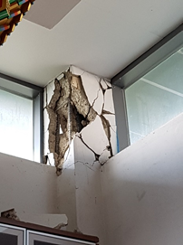

Figure 1 Short-column shear failure observed in the 912 Gyeongju earthquake

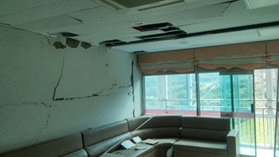

Figure 2 Cracking of infilled wall and ceiling failure observed in the 912 Gyeongju earthquake

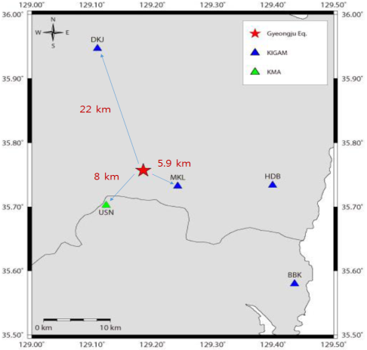

Figure 3 Distances from the epicenter to the measuring stations

ANALYSIS OF MEASURED GROUND MOTIONS

The main shock of the 912 Gyeongju earthquake was reported to be M5.8 on the local magnitude scale (Richter scale) and M5.5 on the moment magnitude scale, and the focal depth was 12km according to the Korea Institute of Geoscience and Mineral Resources (KIGAM). Below is a summary of the analyses using the acceleration records measured by the three stations, two of which were relatively near the epicenter (see Table 1 and Fig. 3). It was speculated that the MKL and DKJ stations belong to rock site condition (S_{B}) while the USN station has stiff soil condition (S_{C}).

The 100Hz sampling rate data originally provided by KIGAM were filtered-out for 25Hz and higher. Table 2 summarizes the PGA (Peak Ground Acceleration) observed in the three stations. As shown in Table 2, the PGA of MKL (at an epicentral distance of 5.9km) was 0.26g to 0.28g, whereas the PGA of DKJ (at an epicentral distance of 22km) was less than 0.1g due to attenuation. The PGA of USN was 0.35g to 0.4g, which is 1.3 to 1.4 times the PGA of MKL, although it has a longer epicentral distance than MKL, presumably due to surface soil amplification effect. The PGA decreased slightly after the high frequency filtering mentioned above, but the PGA magnitudes of MKL and USN are still high, compared to 22g, the effective peak ground acceleration (EPGA) of the 2,400 year return period in Seismic Zone I according to KBC (Korean Building Code) 2016.

Table 1 Three stations near the epicenter
Station | Latitude | Longitude | Accelerometer | Data logger
MKL | 35.7322 | 129.2420 | ES-T | Q330
USN | 35.7024 | 129.1232 | ES-T | Q730
DKJ | 35.9468 | 129.1089 | CMG-5T | Q330HRS

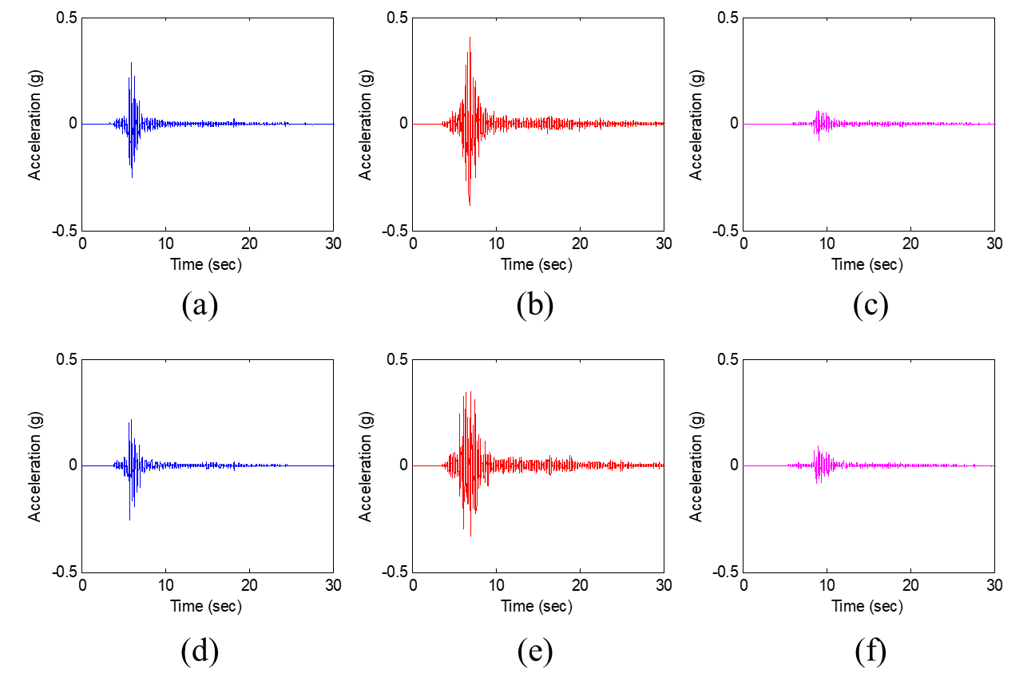
Figure 4 Time histories of horizontal ground acceleration components at three stations
(a) MKL E-W (b) USN E-W (c) DKJ E-W (d) MKL N-S (e) USN N-S (f) DKJ N-S

The horizontal ground accelerations observed at the three stations are plotted in Fig. 4. At first, the cumulative damage potential to structures is expected not that significant since the strong motion duration is very short. In order to quantitatively calculate the strong motion duration, the concept of Arias intensity was used per Equation (1) below:

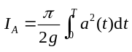 (1)

In this equation, a, T, and g refer to the ground acceleration, the total duration of motion, and acceleration of gravity, respectively. The results of the calculated Arias intensity and strong motion duration are summarized in Table 3, where D_{a5-75} and D_{a5-95} represent the time duration for the input energy to increase from 5% to 75% and 95% of the total, respectively. It is noted that D_{a5-75} is only 1 to 2 seconds long, while D_{a5-95} shows relatively longer duration. The strong motion durations in Table 3 appear too short to induce significant repetitive and cumulative damage to structures.

Table 2 PGA, EPGA and spectral acceleration
Station | Component | Raw accelerograms | Filtered accelerograms
Station | Component | PGA (g) | PGA (g) | EPGA (g) | EPGA/PGA | Sa(1.0) (g) | Sa(1.0)/PGA
MKL | E-W | 0.346 | 0.285 | 0.153 | 0.54 | 0.031 | 0.11
MKL | N-S | 0.275 | 0.257 | 0.164 | 0.64 | 0.053 | 0.21
DKJ | E-W | 0.091 | 0.079 | 0.039 | 0.49 | 0.016 | 0.20
DKJ | N-S | 0.098 | 0.092 | 0.084 | 0.91 | 0.026 | 0.28
USN | E-W | 0.400 | 0.404 | 0.293 | 0.72 | 0.031 | 0.08
USN | N-S | 0.430 | 0.351 | 0.192 | 0.55 | 0.026 | 0.07

It is well known in earthquake engineering that PGA itself, which is the peak value of the ground motion and often not repititive, is just a weak damage potential indicator, especially when it is formed as a high frequency pulse (see Fig. 5). For this reason, the EPGA (Effective Peak Ground Acceleration) defined per Equation (2) below is more favored in modern seismic design. It is calculated by dividing the short-period average spectral acceleration by a factor of 2.5 according to Newmark’s spectrum theory.

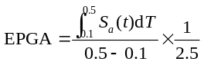 (2)

If some record is of high-frequency pulse-type with short duration, the EPGA is usually much smaller than the apparent PGA. This can be seen in Table 2 where the EPGAs barely reach 70% of the PGAs, except for DKJ N-S.

Table 3 Arias intensity and strong motion durations
Site condition | S_{B} |  |  |  | S_{C}
Station | MKL |  | DKJ |  | USN
Component | E-W | N-S | E-W | N-S | E-W | N-S
I_{A} | 0.225 | 0.170 | 0.023 | 0.046 | 0.698 | 0.675
D_{a5-75} (sec) | 0.76 | 0.79 | 1.85 | 1.32 | 1.37 | 1.89
D_{a5-95} (sec) | 1.80 | 1.87 | 11.03 | 6.10 | 5.89 | 10.13

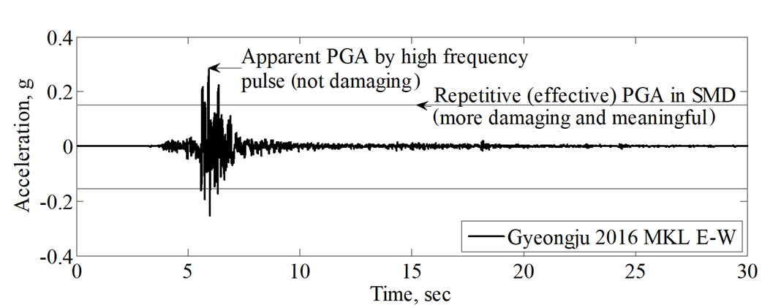
Figure 5 PGA versus EPGA of MKL E-W

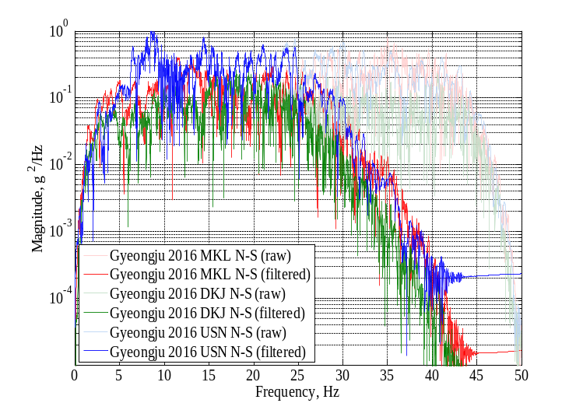
Figure 6 Fourier amplitude spectra of the recorded accelerograms

In order to analyze the frequency contents of the measured ground accelerations, Fourier transform was performed, and the results are shown in Fig.6. First of all, it is observed that most of the vibrational energy was concentrated in the high frequency band over 10 Hz. This frequency distribution means that damage will occur mainly in short-period buildings with a fundamental period of less than 0.1 sec, and is consistent with the actual damage reported in the 912 Gyeongju earthquake.

The response spectra plotted in Fig.7 again strongly indicate that the damages to short-period structures (one to three-story) would be more significant while damages to the longer period structures (longer than 0.3 sec) are expected to be only minimal. In particular, since the duration of the strong motion is as short as 1 to 2 sec, the cumulative damage is very difficult to occur. All these well explain the reason why low-rise (stiff) non-ductile buildings were the most vulnerable during the 912 Gyeongju earthquake.

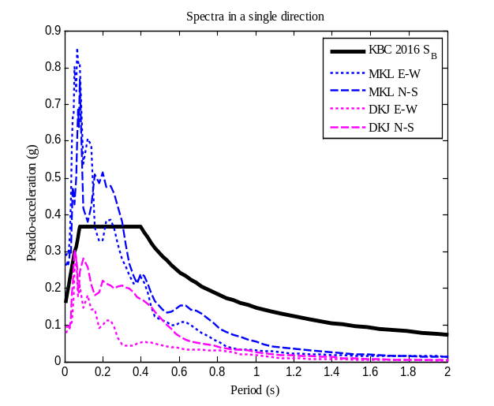 | 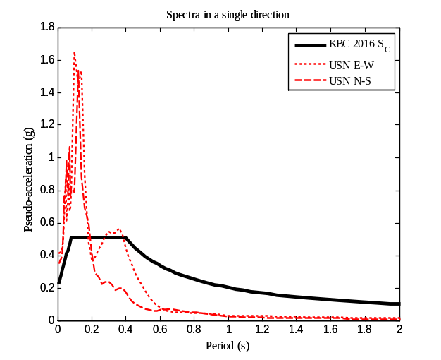
(a) Site condition S_{B} | (b) Site condition S_{C}
Figure 7 Response spectra from 912 Gyeongju earthquake records and design spectrum of KBC

CONSTANT DUCTILITY SPECTRUM AND COMPARISON OF INELASTIC RESPONSE

In order to further understand the damage potential of the 912 Gyeongju earthquake, compared are in this section the constant ductility spectra that were constructed by using the ground motions from the 912 Gyeongju earthquake and the 1940 El Centro earthquake in the US. The 1940 El Centro records have been widely used as a “standard” strong ground motion in modern seismic engineering (see Table 4). Fig. 8 shows a comparison of the two input accelerograms, El Centro 1940 S00E and Gyeongju 2016 USN N-S.

Table 4 1940 El Centro earthquake record
 | Magnitude | Epicentral distance (km) | Comp. | PGA (g) | Site
Imperial Valley 5/18/1940, El Centro | 6.9 | 11.5 | S00E | 0.348 | Alluvium

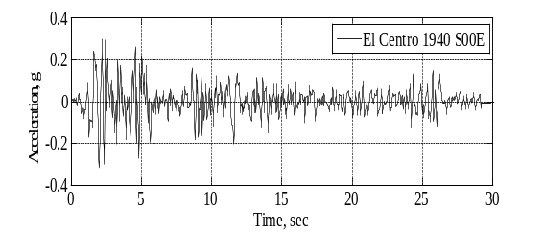 | 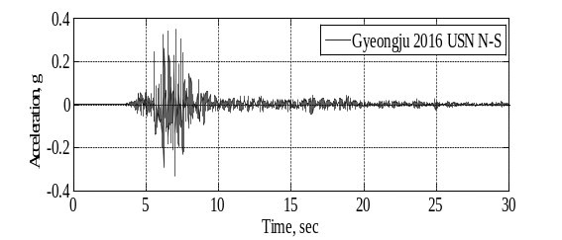
Figure 8 Comparison of two accelerograms; El Centro 1940 S00E and Gyeongju 2016 USN N-S

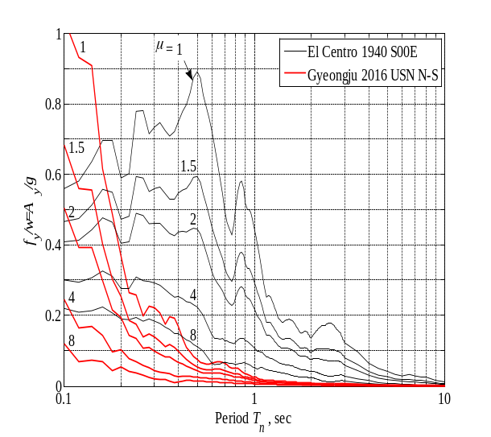
Figure 9 Comparison of constant ductility spectra from El Centro 1940 S00E
and Gyeongju 2016 USN N-S components

The constant ductility spectrum gives the yield strength level of a structure required to limit the ductility demand below the prescribed magnitude. Fig. 9 shows a comparison of the constant ductility spectra constructed from the El Centro 1940 S00E and Gyeongju 2016 USN N-S components for μ (ductility level) of 1, 1.5, 2, 4, and 8. The vertical axis represents the required base shear strength normalized by the weight of the structure.

Several observations can be made from Fig. 9 as follows. First, base shear demand from Gyeongju 2016 USN N-S component is very high just for very stiff and brittle structures (with ductility capacity less than 2). However, strength supply required by Gyeongju 2016 USN N-S component is drastically reduced as structural period is increased beyond 0.2 sec. and becomes almost null in the velocity- and displacement-sensitive spectral regions. Thus, short-period structures (1~2 story buildings) with poor or brittle construction were the most vulnerable in the 912 Gyeongju earthquake as was really observed. Building structures of average construction with periods longer than 0.3~0.4 sec. would resist the tremors similar to the 912 Gyeongju earthquake with little damage. As was noted in Fig. 6, the vibrational energy concentrated in the high frequency band over 10 Hz cannot excite multi-building structures effectively.

Nonlinear time-history analysis was further conducted for 0.1 sec (short-period) and 1.0 sec-period (mid-period) structures. The yield strength f_{y} of each structure was assumed as 10% of the structure weight (W). The analysis results are presented in Fig. 10 and Fig. 11 respectively for 0.1 sec (short-period) and 1.0 sec-period (mid-period) structures.

Fig. 10 shows that the El Centro record is much more destructive, requiring the impossible ductility capacity of 60 or more while the ductility demand from the 912 Gyeongju record is much less (6.8) but still formidable to achieve in practice. However, the structure with mid-period of 1.0 sec. can resist the 912 Gyeongju record elastically with sufficient margin with a base shear strength level of f_{y}=0.10W (see Fig. 11). The constant ductility spectra in Fig. 9 and these nonlinear analysis results clearly indicate that except for the very stiff and brittle structures with ductility capacity less than 2, the damage potential of Gyeongju 2016 USN N-S is extremely low compared to the El Centro 1940 S00E.

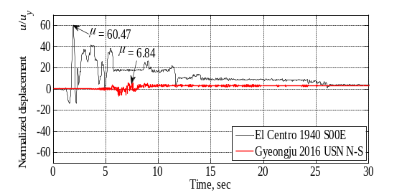 | 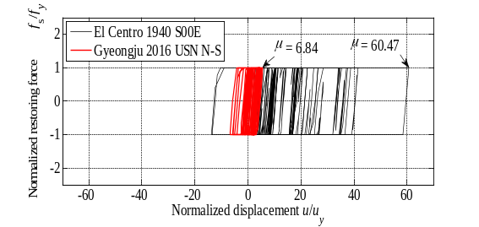
(a) Normalized displ. time history | (b) Normalized hysteresis
Figure 10 Inelastic response of 0.1 sec (short period) structure with f_{y}=0.10W

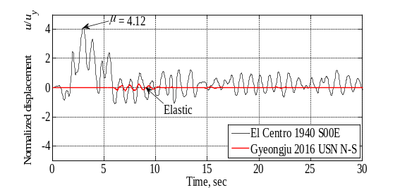 | 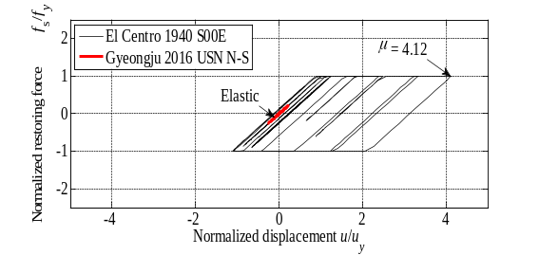
(a) Normalized displ. time history | (b) Normalized hysteresis
Figure 11 Inelastic response of 1.0 sec (mid period) structure with f_{y}=0.10W

SUMMARY AND CONCLUSIONS

The 912 Gyeongju earthquake was the first “instrumental earthquake” which caused non-negligible structural and non-structural seismic damage in Korea, and has effectively invalidated the misbelief among many people that only weak earthquakes around M5 would occur in Korea. This earthquake is now serving as an event for the Korean government and people to admit that earthquakes are a real threat that we can face anytime.

However, the overall damage caused by the Gyeongju earthquake was minor compared to the apparent magnitude because the strong motion duration was short and the seismic energy was mainly concentrated in the high frequency range over 10 Hz, thus causing seismic damage mostly in low rise and/or poor building construction.

Strength supply required by the 912 Gyeongju earthquake record to limit ductility demand is drastically reduced as structural period increases and becomes almost null in the velocity- and displacement-sensitive spectral regions.

It is also speculated that the 912 Gyeongju earthquake may represent the characteristics of earthquakes typical of Korean peninsula; relatively short strong motion duration dominated by high frequency components. However, inelastic analysis showed that ductility demand can be substantial for short-period structures even with a yield base shear ratio as high as 10% building weight.

Further extensive studies from the perspective of both seismic design and engineering seismology are warranted to identify the unique damage potential of the earthquakes expected to strike Korean peninsula.

Proper and cost-effective measures should be taken to salvage poorly constructed and inherently brittle low-rise buildings. Nonstructural damage which may cause injuries as well as malfunctioning should be properly addressed as well.

The 912 Gyeongju earthquake should be considered as the Early Warning Earthquake for Korea. All the lessons learned from this earthquake should be reflected in future actions, technological and institutional, to establish seismically resilient Korea in a socio-economically acceptable way.

REFERENCES

Lee, C. H. (2016), “Damage Potential of the 912 Gyeongju Earthquake and its Implications in Seismic Engineering,” Special Session at the 2016 Earthquake Engineering Society of Korea Fall Conference Commemorating its 20th Anniversary, September 23, 2016.

Lee, C. H. (2016), “Current Seismic Design Practice in Korea and Engineering Implications of Recent M5.8 Gyeong-Ju Earthquake,” Special International Workshop for Earthquake Preparedness of Korea, 2016 AIK Annual Convention, BEXCO, Busan, October 5.

Lee, C. H., Park, J. H., Kim, T. J., Kim, S. Y., Kim, D. K (2016), “Damage Potential of 912 Gyeongju Earthquake (M5.8) and its Implications in Seismic Engineering,” Journal of the Earthquake Engineering Society of Korea, Special Issue (December).

Lee, C. H (2016), “Lessons from the 912 Gyeongju Earthquake and Seismic Design,” Korea Iron & Steel Association Bulletin (Nov, 2016), Korea Iron and Steel Association.

Professor, Seoul National University, Korea, e-mail: ceholee@snu.ac.kr

